Kootenai Shoshone Soil and Water Conservation District
7830 Meadowlark Way, Ste. C-1
Coeur d'Alene ID 83815
208.209-4348

“Putting conservation on the ground by promoting stewardship”

Minutes

Date: September 11,2024

Present Absent (Board members)

Laurin Scarcello – Chairman Jenna Ditzel - ISWCC
Linda Ely – Vice – Chairman Bill Lillibridge , ISWCC
Wes Evans – Secretary/Treasurer
Bob Flagor, Associate Supervisor
Jon Groth – Supervisor
John Mobbs – Associate Supervisor
Joel Noland - Supervisor
Joe Kevin Hicks – Supervisor
Thomas Shaffer- Supervisor
Karla Freeman, KSSWCD
Corey Bonsen- NRCS
David Muise – Kootenai Environmental Alliance
Patrick Adair- Wing Rising, Inc.
Paul Mallow – Landowner/Candidate for Election 2024

The meeting was held at the NRCS Conference Room located at 7830 Meadowlark Way Suite C-1, Coeur d’Alene, ID 83815.

Meeting called to order by Chairman Laurin Scarcello at 9:00 am.

Introductions were made around the room.

Wes Evans moved, and Joel Noland seconded the motion to approve August’s 2024 meeting minutes. MOTION CARRIED.

Linda Ely moved, and Joel Noland seconded the motion to approve August’s financial report. MOTION CARRIED.

Next on the agenda was Corey Bonsen, NRCS.

Staffing and Office
- We advertised our Admin position for the 4th time. We should be getting the certificates of applicants any day now. HR apparently made some kind of mistake and had to re-advertise it again, after we had already completed the interviews. Hopefully they get it right this time and we will receive some qualified candidates.

Local Working Group
- The meeting is scheduled for October 29th from 1-5 at the IDL building on Industrial Loop in Coeur d’Alene. Same place as the past few years.

Environmental Quality Incentives Program (EQIP)
- Our timelines for our FY25 programs are out, and the sign-up deadline for our general EQIP will be October 4th. This is for the majority of our EQIP funding.
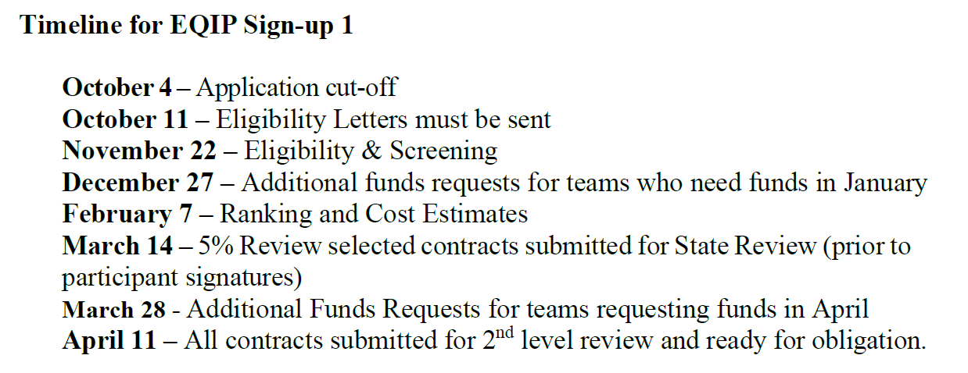
- With the state deciding to keep the Inflation Reduction Act (IRA) funds as Act Now, these deadlines are a bit misleading. Landowners with qualifying practices can sign up through March 7th and still be considered for FY25 funding.

- The EQIP sign up 2 deadline is April 4th, however it is limited to specific pools.
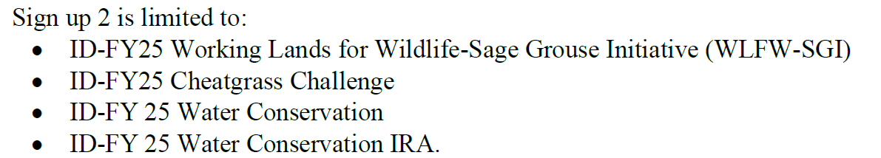

Civil Rights –
Hispanic Heritage Month
During National Hispanic Heritage Month (September 15 to October 15) we recognize the contributions made and the important presence of Hispanic and Latino Americans to the United States and celebrate their heritage and culture. Hispanic Heritage Month begins each year on September 15, the anniversary of independence of five Latin American countries: Costa Rica, El Salvador, Guatemala, Honduras and Nicaragua. Mexico, Chile and Belize also celebrate their independence days during this period and Columbus Day (Día de la Raza) is October 12.

As always, board members are welcome to request civil rights training from NRCS.

Next on the agenda is Jenna Ditzel, ISWCC- Jenna is not here but has provided a handout on the updates with the Idaho Soil and Water Conservation Commission. (See handout)

Next on the agenda is Karla Freeman, District Administrator:

Karla updated on the following projects:

No-till drill- We have already rented this drill out once to a local landowner who drilled 125 acres. We have also received the first reimbursement request from DEQ for $55,000.

Boat Stations –Busy as usual, no new news to report.

Karla reminded the board of the upcoming Fall 2024 division meeting to be held on Tuesday October 22, 2024. The location has not been announced yet.

Annual Audit – Andeson Brothers are currently working on the audit. Hopefully we will have this back in the next few months.

Leading Idaho- Toedter Property – Larry Mundt- This project is completed and waiting for inspection from Bill Lillibridge and Jenna Ditzel so we can close out the grant and submit the final reimbursement as well as the final report.

Leading Idaho – Andrew LeClaire- Bill completed the designs for the culvert replacement and should be finishing this up sometime in late September or October.

Leading Idaho – Albert Walsh – This project should be completed in late September or early October.

319 – The District will be presenting on the two (2) applications that were submitted at the upcoming BAG meeting on Thursday October 17, 2024. They are both streambank restoration projects, both landowners live in Shoshone County, one is Tammi Atkins and the other is Cindy Bass. The meeting will be held at the DEQ office in Coeur d’Alene.

Credit Cards- We are officially set up on the credit card system and have already started accepting payments using this method. We are charging the 3% fee to the purchaser.

Next on the agenda is David Muise with the Kootenai Environmental Alliance to do a presentation on Climate Adaptation Project. (see power point presentation print out).

Next on the agenda is the Wings Rising presentation and the request for funding for the Forest Service Project. Joel Noland motioned to sponsor a match of not to exceed 50% ($1,694.00) of the total project at the Forest Service Nursery of $ 3,388.00. Jon Groth seconded the motion. MOTION CARRIED.

Next on the agenda was the discussion of the first no till drill rental. The drill was picked up by the landowner. The drill was not working properly so John Mobbs went out to the landowner’s property to trouble shoot and was able to get the drill up and running by adding 600 lbs. of suitcase weights to the drill. The drill was slightly damaged and will be fixed at the expense of the landowner per the rental contract. The landowner did 125 acres.

Next on the agenda is Jon Groth with the Silver Valley updates. Jon updated that he had reached out to the Shoshone County Commissioners concerning funding for 2024 and was told they have a really tight budget this year but has the district set up to receive $ 750.00 for yearly allocation. They also advised Jon to request a meeting just after the 4th of July 2025 to set up a meeting so the district can make a formal request for the 2025 year. This will be added to the calendar to do.

Jon updated on the Kingston Sewer and Water District that the ongoing project is still moving forward. They are currently waiting for final approval of designs from DEQ. Once the final designs are approved then the project will go out for public bids.

Jon also reminded the board of the open house that will be held at his tree farm on Saturday September 14, 2024. Transportation to the farm will be provided as well as lunch. This event is open to all that are interested.

Thomas Shafer addressed the board concerning the test results on the biosolids from a previous presentation to the board in July 2024 from Ken Windham with the Hayden Sewer board. Discussions were had around the room concerning the need for additional testing on the biosolids for heavy metals, micro-plastics, pharmaceuticals, etc. What role would the board need to have in this? This will be added to the October 2024 agenda as a discussion item.

Next meeting will be on Wednesday October 9,2024, at 9:00 am.

The meeting adjourned at 11:40 am.

